Class activity

1. ArithmeticException – Student Average

import java.util.*;

public class Average {
public static void main(String args[]) {
Scanner sc = new Scanner(System.in);

try {
System.out.print("Total Marks: ");
int total = sc.nextInt();

System.out.print("Subjects: ");
int sub = sc.nextInt();

System.out.println("Average = " + (total / sub));
}
catch (ArithmeticException e) {
System.out.println("Cannot divide by zero.");
}
}
}

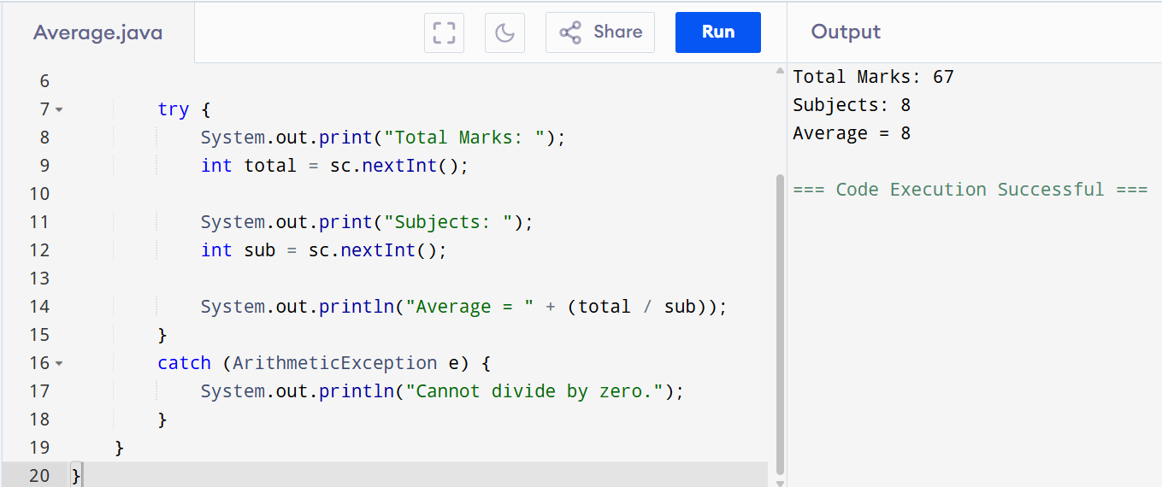

2. NullPointerException – Employee
class Employee {
String name;
}

public class Demo {
public static void main(String args[]) {

Employee e = null;

try {
System.out.println(e.name);
}
catch (NullPointerException ex) {
System.out.println("Employee object is null.");
}
}
}

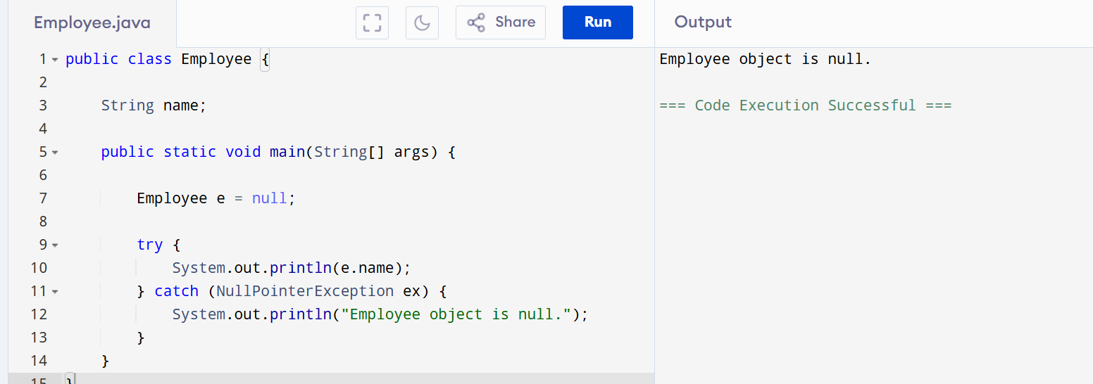

3. ArrayIndexOutOfBoundsException – Student Marks
import java.util.*;

public class Marks {
public static void main(String args[]) {

Scanner sc = new Scanner(System.in);

int marks[] = {80, 70, 90, 60, 85};

try {
System.out.print("Enter Index: ");
int i = sc.nextInt();

System.out.println(marks[i]);
}
catch (ArrayIndexOutOfBoundsException e) {
System.out.println("Invalid Index.");
}
}
}
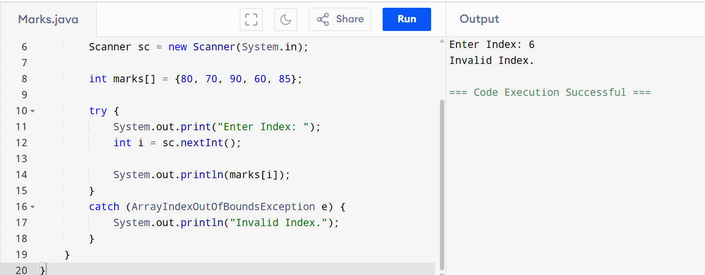

4. NumberFormatException – Customer Age

import java.util.*;

public class Customer {
public static void main(String args[]) {

Scanner sc = new Scanner(System.in);

System.out.print("Enter Age: ");
String age = sc.nextLine();

try {
int a = Integer.parseInt(age);
System.out.println(a);
}
catch (NumberFormatException e) {
System.out.println("Invalid Age.");
}
}
}
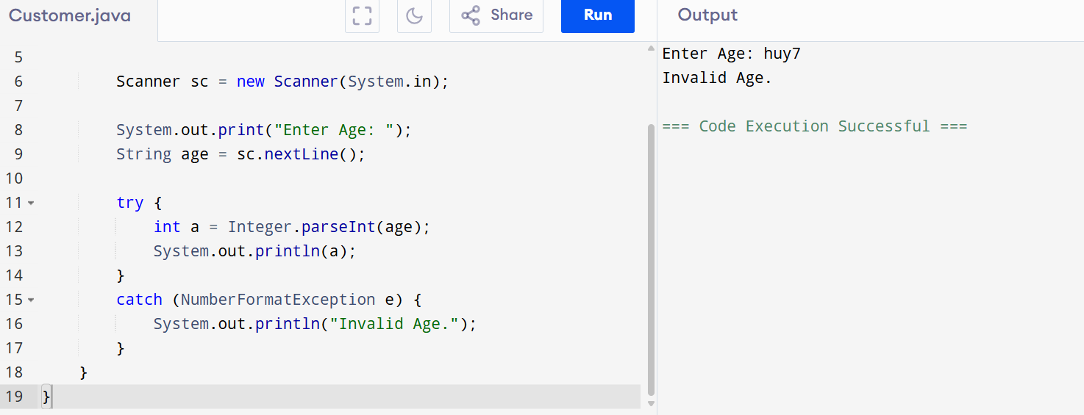

5.ArithmeticException (division by zero).

public class DivideByZero {
public static void main(String[] args) {

int num = 10;
int den = 0;

try {
int result = num / den;
System.out.println("Result = " + result);
}
catch (ArithmeticException e) {
System.out.println("Cannot divide by zero.");
}
}
}
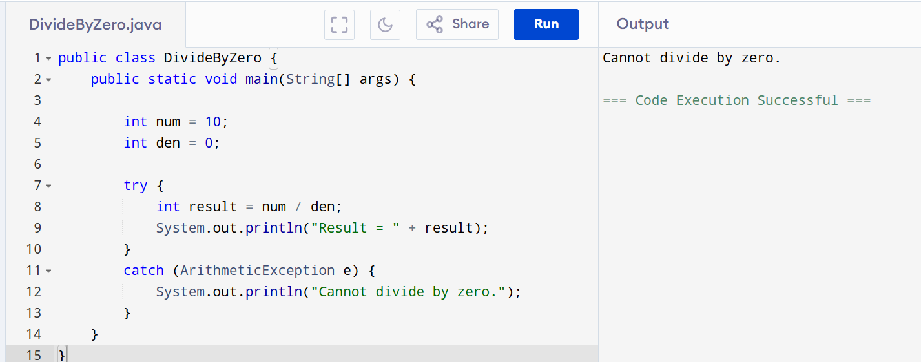

6.NullPointerException.
public class NullString {
public static void main(String[] args) {

String s = null;

try {
System.out.println("Length = " + s.length());
}
catch (NullPointerException e) {
System.out.println("String is null.");
}
}
}
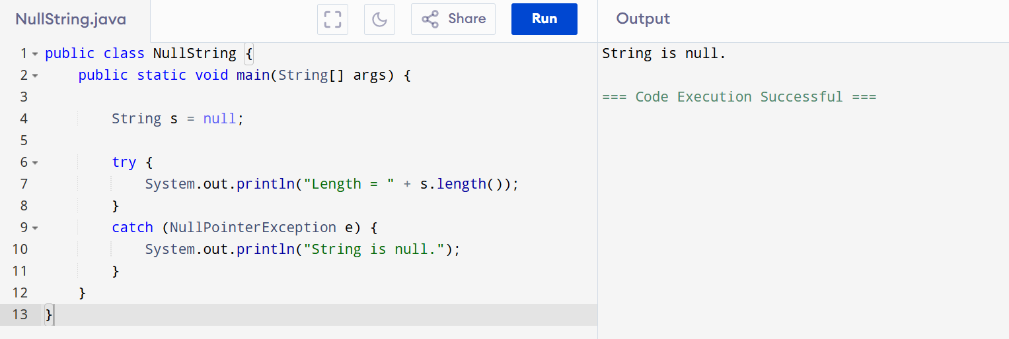

7.NumberFormatException
public class NumberFormatDemo {
public static void main(String[] args) {

String s = "abc";

try {
int i = Integer.parseInt(s);
System.out.println(i);
}
catch (NumberFormatException e) {
System.out.println("Invalid number.");
}
}
}
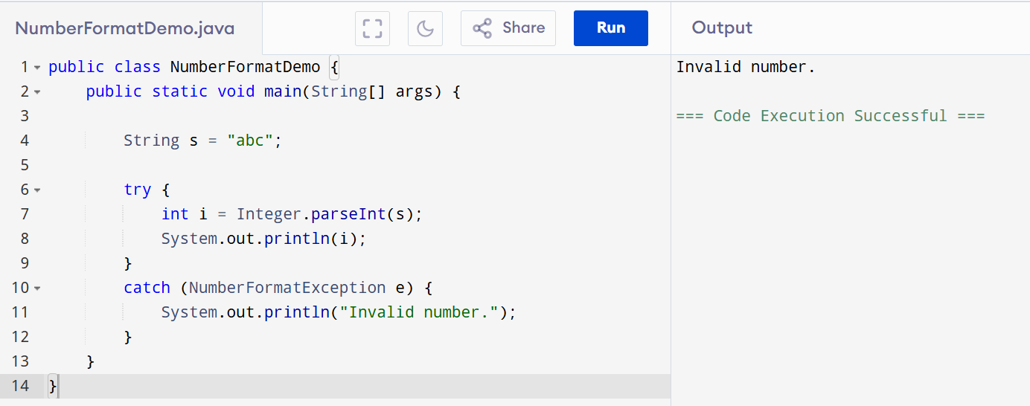

8.ArrayIndexOutOfBoundsException
public class ArrayDemo {
public static void main(String[] args) {

int a[] = new int[5];

try {
a[10] = 50;
System.out.println(a[10]);
}
catch (ArrayIndexOutOfBoundsException e) {
System.out.println("Array index is out of bounds.");
}
}
}
